L01_Hillary_Dreyer Bruton_ITAI2372

Proof of Completed Lab:

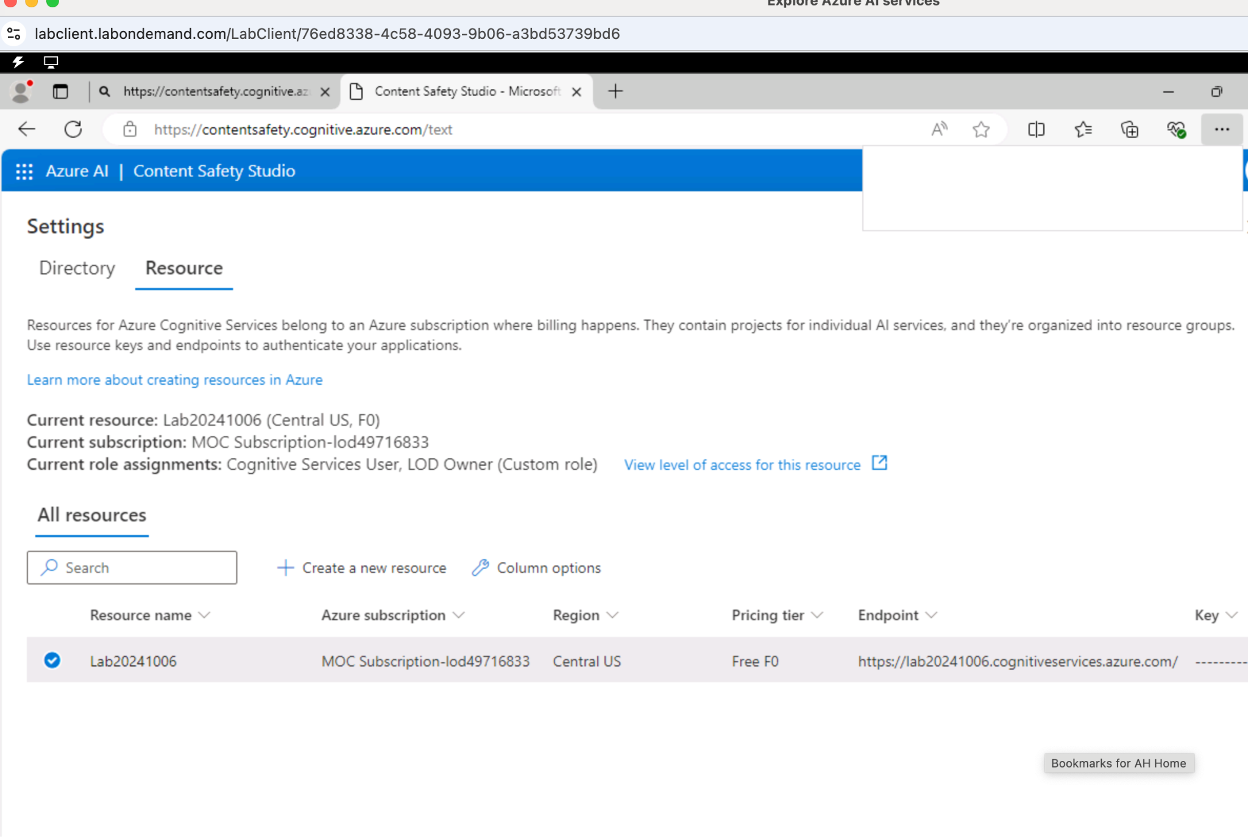

Lab 01 Reflective Journal:

What did I learn?

I was introduced to the Azure Content Safety Studio for the first time, so everything I experienced today was new information to me. I learned that assigning resources is very easy.

What were challenges I faced?

Overall, I felt that the lab was easy to follow and easy to digest the inofrmaion presented. The biggest challenge with today’s lab was trying to figure out the flow of how these labs work and navigating the MSLE Skillable Platform.

What were insights gleaned?

I didn’t really gain any key insights nor did I have any important revelations. Today’s lab work was primarily focused on familiaring oneself with the platform